OCEANA COUNTY 4-H MARKET LIVESTOCK
EDUCATIONAL NOTEBOOK/RECORD

LAMB PROJECT - 2024
AGES 15-19
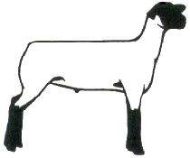
As a member of the 4-H Market Livestock Lamb project you are required to submit your records as part of an educational project notebook in order to sell your animal at the 4-H Market Livestock Sale. This notebook must be shown to the Oceana County 4-H Market Livestock Committee's Weighmaster at the time of weigh-in and then entered by you in the Educational Notebook Division of the Oceana County Fair on Entry Day.

AGE: ________

Remember: The age you enter depends on how old you are or will be on Jan. 1, 2024

Number of years in project: ________

Use this sheet as the first page of your project record book. Fill it out completely.
Please print or type neatly.

NAME_______________________________________________________________________

4-H CLUB____________________________________________________________________

BREED________________________________LAMB’S NAME__________________________

DATE OF BIRTH___________________ DATE RECORD STARTED_____________________

LOCATION WHERE ANIMAL IS RAISED __________________________________________



JUDGE’S SCORE/COMMENT SHEET

(PLEASE DO NOT: REMOVE, PLACE THIS SHEET IN SHEET PROTECTOR, OR GLUE TO COVER). This sheet must be kept free for the judge to write their comments.

This sheet should help each 4-H’er understand their ribbon placing.

A. Specific educational value or worth

___ All questions were answered completely

___ All calculations were correct

___ Calculations were incorrect

___ Questions were not completely answered

___ Questions were not answered (missed questions)

B. Notebook contains all project records

___ Notebook contained all project records and were fully completed

___ Notebook contained additional project related information (research

materials etc.)

___ Project records were incomplete

___There was no additional project related information

C. Accuracy, neatness and general appearance

___Notebook was neat in appearance (typed/hand printed)

___Notebook pages were clean and stain free

___ Notebook pages were in order and complete

___Notebook pages were out of order and missing pages

___Notebook was difficult to read and messy

__Notebook had wrinkled and stained pages

Other Comments: ______________________________________________________

____________________________________________________________

____________________________________________________________

4-H MARKET LIVESTOCK LAMB NOTEBOOK- 2024
AGES 15-19

TABLE OF CONTENTS

Please keep your notebook in Table of Contents order.

- GENERAL GUIDELINE INFORMATION

- JOURNAL OF CARE

- PROJECT INFORMATION

- SPECIFIC EDUCATIONAL PROJECT KNOWLEDGE

  - Breed Scramble
  - Marketing
  - Lamb Parts Identification
  - Fitting & Showing
  - Wholesale Cuts
  - Sheep By-Products

- MY PROJECT INFORMATION
a) Your Project
b) 4-H Info & Activities

- BUYERS NAMES

- PICTURES OF YOUR PROJECT (1 page)

- NON-CLUB/CLUB POINTS SHEETS

APPENDIXES (OPTIONAL):

- PICTURES OF YOUR PROJECT (additional pictures)
- FEED INFORMATION (example: feed labels etc.)
- ADDITIONAL INFORMATION ABOUT YOUR PROJECT
  - Information you found in reference materials
  - Information you located off the internet
  - Information gathered from your feed representative
  - Any other information
* Include notes as to why you researched this information and found it
Valuable, link it to your project if possible.

Note: Reference materials used for the specific project knowledge include:

a. 4-H Market Livestock Lamb Project Rules
b. Your Sheep – A Kid’s Guide to Raising and Showing
c. 4-H Skills for Life Animal Science Series – Lambs 1, 2 & 3
(All swine leaders have a copy and copy available on check-out system at MSU Extension)
d. Kansas State 4-H Online
e. Lamb Resource Book (The Ohio State University 4-H)
2024- Lamb Record Book (15-19) Page 1

This record is part of your 4-H Market Lamb Project work. By keeping records up to date you will be able to see how much progress you make as you set goals and work to accomplish them. Write neatly and clearly. Feel free to add extra pages.

PROJECT PICTURES

Pictures are a required part of this notebook. Taking pictures of your project animal throughout the project will indicate how your animal has grown and developed. Add pictures to your notebook on a separate piece of paper.

SCORING CRITERIA

The following breakdown will be used during the judging process of all market livestock notebooks.

A. Specific educational value or worth 30%

B. Creative way of showing what has been learned 10%

C. Notebook contains all project records 50%

D. Accuracy, neatness and general appearance 10%

The Oceana County 4-H Market Livestock Committee encourages 4-H Leader and parent assistance with your project and project notebook. If you should have any questions, please contact the MSU Extension Office.

I, ____________________________ assisted ________________________ in
Parent/Leader/Adult Name 4-Her’s Name
understanding the questions and writing the answers. All answers are those of the 4-Her.

____________________________________
Signature of person helping with notebook
If written help was needed

2024- Lamb Record Book (15-19) Page 2

JOURNAL OF ANIMAL CARE

The 4-H Market Livestock Committee is requiring all 4-H Market Livestock members to complete the “Journal of Care”, so the judge may see the time, effort and care you have put into learning about your animal.

** It will be assumed that you walked & fed your animal, but what additional things have you done such as washed, clipped, trimmed, foot care, health practices, medicines, general maintenance (cleaning living area & feed pans), halter breaking, training, had vaccinated, etc. **

APRIL:

MAY:

JUNE:

2024- Lamb Record Book (15-19) Page 3

JOURNAL OF ANIMAL CARE
(cont.)
JULY:

AUGUST:

If not housed at your home, have the property owner sign. If housed at your home, please have your parent sign.

I,___________________________________,do attest and certify that this 4-Her has
(property owner name (please print), if parent -please print
cared for this animal in a responsible manner while housed on my property. I also understand that integrity and responsibility are important to this 4-H experience.

__________________________________ ______________
Signature of Property Owner or Parent Date
If housed on own property

2024- Lamb Record Book (15-19) Page 4

PROJECT INFORMATION

The start of the project will be the date the 4-Her placed the animal on feed, not any later than June 1st of the current year. The end of the project will be weigh-in day at the Fair.

Project Start Date June 1, 2024 Project End Date ________________

Fair Haul In Day

What month was your lamb born? __________________________

Please complete the following chart about your project.

4-H Ear Tag  Number | Breed | Gender | Date of Purchase | Price or value | Estimated Starting Weight | Ending/FinalWeight  (FW) | Total Pounds Gained
Note: Total pounds gained = ending weight – starting weight

MONTHLY FEED RECORD & EXPENSES

Month | Type of feed used-  (grain, roughage, etc.) | Supplements  (if any used) | Amount  (indicate lbs., bales etc.) | Cost of feed used for the month
April
May

2024- Lamb Record Book (15-19) Page 5

MONTHLY FEED RECORD & EXPENSES (cont.)

Month | Type of feed used-  (grain, roughage, etc.) | Supplements  (if any used) | Amount  (indicate lbs., bales etc.) | Cost of feed used for the month
June
July
August
Column Totals

Total Feed Costs for Project $________________
2024- Lamb Record Book (15-19) Page 6

EXPENSES OTHER THAN FEED

The 4-H Market Livestock Committee would like you to keep a running list of all of your expenses -- veterinary charges, bedding, insecticides, trucking, insurance, interest paid on money borrowed, housing etc. Even if your parents pay for these items, figure out how much your animal needs and or uses as this is an expense of YOUR project.

 | Vet  Charges | Bedding | Insecticides | Equipment | Trucking | Housing/Rent | Shearing or  Clipping | Advertising/  Marketing | Miscellaneous (specify)  Include 4-H enrollment | Buyer Recognition | MONTHLY TOTAL
APR
MAY
JUNE
JULY
AUG
TOTALS

2024- Lamb Record Book (15-19) Page 7

PROJECT EFFICIENCY INFORMATION

(using figures from page 4,5 and 6)

Value of Animal at Time of Purchase = ___________

__________________ ÷ ______________ = __________________________
Total lbs. of Gain Days on Feed Average Daily Rate of Gain
(from page 4)

_______________ ÷ __________________ = __________________________
Total Feed Cost Total lbs. of gain Feed Cost per lbs. of Gain

______________________÷__________________=___________________________
Total lbs. of feed fed Total lbs. of gain Lbs. of Feed Fed per lb. of Gain

_________________ + ______________ + ______________ = ______________ (TE)
Total Feed Expense Cost of Animal Other Expenses Total Project Expense

Lambs are sold by the pound at a Large Animal Sale Auction. Find out what bid price (per lb.) you need to get at the Large Market auction to breakeven (BE) on your market lamb project.

__________________÷____________________= ____________________________
Total Expenses (TE) Final Weight (FW) Break Even Price (BE)
(or total cost per lb. to raise your animal)

What is the current selling price of lamb (per lb.)? _____________________________

Where did you find the current selling price? ________________________________
(if your source was a person, ask them where they got this information)

Would you have been able to make a profit selling on the open market? __________

Why or why not? _______________________________________________________

_____________________________________________________________________

_____________________________________________________________________

2024- Lamb Record Book (15-19) Page 8

PROJECT KNOWLEDGE

Lamb Parts Identification
WORD BANK

RUMP
LOIN
RIBS
EYE
EAR
MOUTH
SHOULDER
FOREARM
HOOF
DEW CLAW
STIFLE
BELLY
HOCK
THIGH
LEG OF LAMB
TWIST
REARFLANK
FOREFLANK
SHANK
PASTERN
KNEE
BREAST
NECK
FACE
FOREHEAD
POLL
BACK
HIP
DOCK

Identify the parts and list them with their corresponding number.
15-19 Answer All
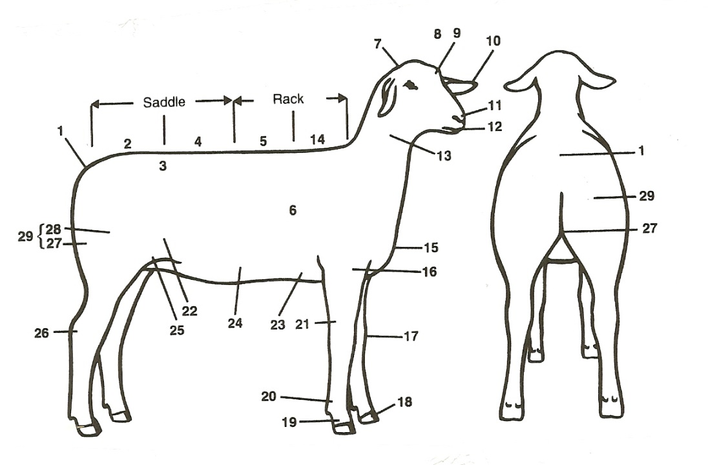

1. _______________________ 16. ________________________
2. _______________________ 17. ________________________
3. _______________________ 18. ________________________
4. _______________________ 19. ________________________
5. _______________________ 20. ________________________
6. _______________________ 21. ________________________
7. _______________________ 22. ________________________
8. _______________________ 23. ________________________
9. _______________________ 24. ________________________
10. ______________________ 25. ________________________
11. ______________________ 26. ________________________
12. ______________________ 27. ________________________
13. ______________________ 28. ________________________
14. ______________________ 29. ________________________
15. ______________________

2024- Lamb Record Book (15-19) Page 9

MARKETING

One of the most important parts of any market animal project is marketing. This includes writing a letter, talking to buyers and making sure you thank your previous buyers in a timely fashion.

- What did you do to market your animal this year?
- If you have participated in a market livestock project before what did you do differently in marketing your animal this year?

______________________________________________________________________

______________________________________________________________________

______________________________________________________________________

______________________________________________________________________

STRUTCTURAL SOUNDNESS- Legs/Stance Front View

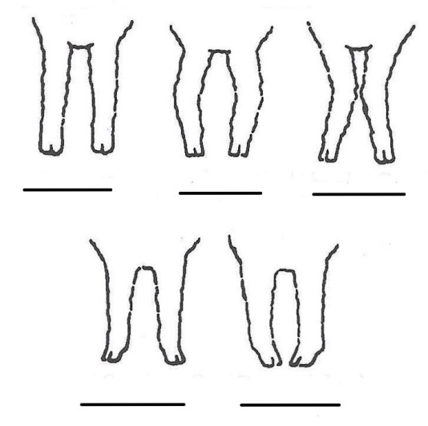
Which lamb would you choose? Put the letter to the correct description under the correct view.

A. KNOCK-KNEED

B. PIGEON-TOED

C. CORRECT

D. SPLAYFOOTED

E. BOWLEGGED

2024- Lamb Record Book (15-19) Page 10

WHOLESALE CUTS
Write the letter that corresponds to the correct WHOLESALE cut:

_____ BREAST

_____ FORESHANK

_____ LEG

_____ LOIN

_____ RACK

_____SHOULDER
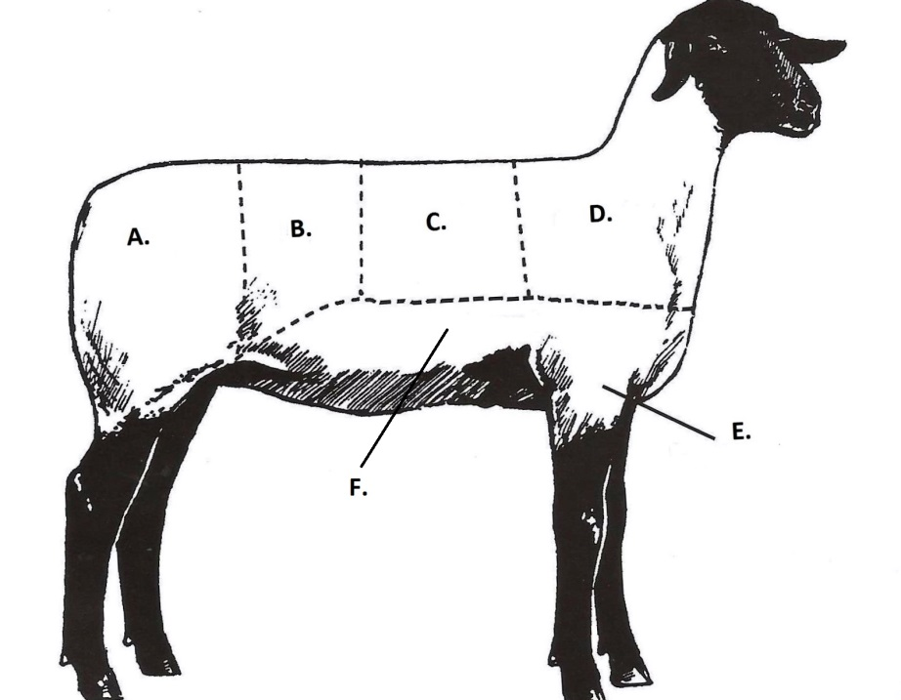

2024- Lamb Record Book (15-19) Page 11

JUST FOR FUN- Sheep Behavior
Complete the following word scramble. Each “jumble” of letters spells a word found regarding sheep behavior. Using the clues, decipher the words and write them out in the spaces provided. To check yourself, write down (in order) all the circle letters in the spaces at the bottom of the page. Use the word key below for possible solutions to the jumbles.

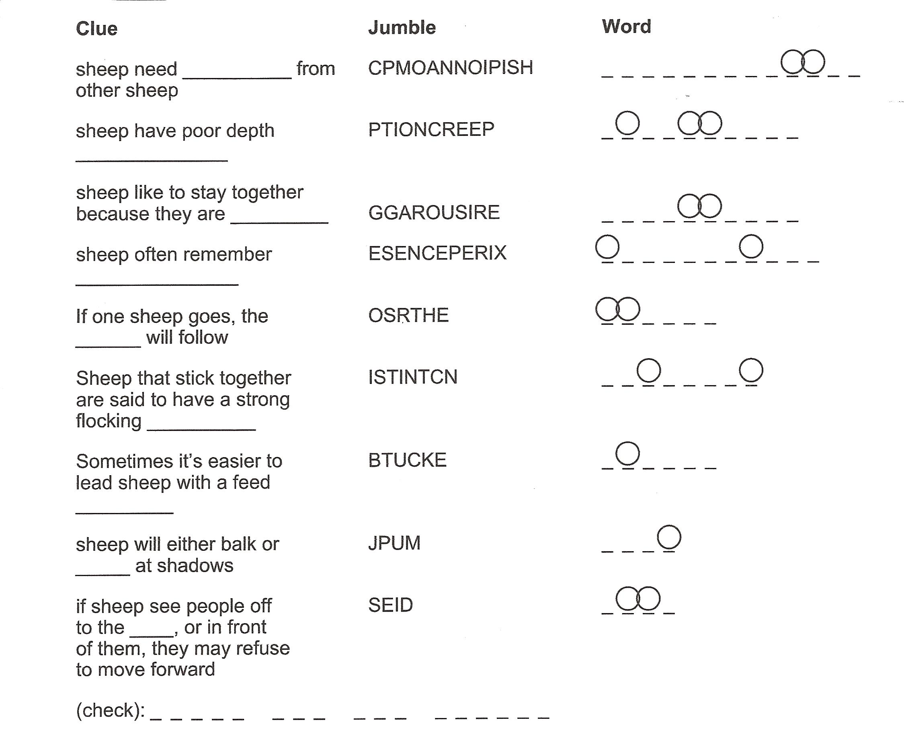

Key:
BACKSIDE DELIVERY GANGLY OUTSIDE
BLANKET EXPERTS HEALTHY OTHERS
BUCKET EXPERIENCES INSTINCT PERSPECTIVE
COMMUNICATION FLOCK JOLT PERCEPTION
COMPANIONSHIP GREGARIOUS JUMP SIDE
(courtesy of Kansas State 4-H Youth Programs-online)

(courtesy of Kansas State 4-H Youth Programs-online)

2024- Lamb Record Book (15-19) Page 12

Breed Word Search

P | D | N | A | L | T | E | H | S | I | S | O | V | A | W
Z | O | K | D | T | J | B | I | L | X | O | I | D | I | O
O | R | O | M | N | E | Y | L | S | C | U | P | R | B | R
X | S | H | S | M | W | C | B | A | H | T | E | N | M | K
I | E | R | K | X | T | K | D | L | U | H | C | Y | U | E
C | T | O | I | V | E | H | C | G | N | D | N | K | L | R
U | A | S | B | D | F | V | K | E | Z | O | J | R | O | I
V | L | J | H | O | J | Y | R | B | D | W | Y | E | C | H
B | X | N | I | K | T | I | D | R | F | N | T | T | M | P
Y | S | G | F | W | H | A | O | C | U | M | R | S | C | O
T | J | B | N | S | U | F | F | O | L | K | B | E | J | R
N | G | A | P | O | X | M | J | L | C | N | K | C | S | H
R | R | M | G | O | V | S | M | F | Y | L | S | I | B | S
M | A | F | H | U | W | B | F | D | U | Q | I | E | R | D
H | V | X | F | R | A | M | B | O | U | I | L | L | E | T
1. SUFFOLK 2. DORSET 3. COLUMBIA
4. HAMPSHIRE 5. CHEVIOT 6. OXFORD
7. ROMNEY 8. RAMBOUILLET 9. SOUTHDOWN
10. LEICESTER 11. SHROPSHIRE 12. SHETLAND

2024- Lamb Record Book (15-19) Page 13

your project

1. When you selected your market lamb, what factors did you consider?

______________________________________________________________________

______________________________________________________________________

_____________________________________________________________________

Are you happy with the breed you chose?_____________________________________

______________________________________________________________________

2. What are 2 marketable features of your animal that you would share with potential buyers?
______________________________________________________________________

______________________________________________________________________

_____________________________________________________________________

3. What feature(s) of your market lamb could use some improvement?

______________________________________________________________________

______________________________________________________________________

_____________________________________________________________________

4. Will you participate in a market lamb project again? ___________________________

Why or why not? ______________________________________________________

______________________________________________________________________

______________________________________________________________________

______________________________________________________________________

2024- Lamb Notebook (15-19) Page 14

4-H INFORMATION
The 4-H Pledge

I pledge…..

___________________________________________________________________________________,

____________________________________________________________________________________

____________________________________________________________________________________

____________________________________________________________________________________

____________________________________________________________________________________

____________________________________________________________________________________

The 4-H MOTTO:______________________________________________________

List 1 way that you helped or taught others this year:

_____________________________________________________________________

_____________________________________________________________________

_____________________________________________________________________

_____________________________________________________________________

2024- Lamb Notebook (15-19) Page 15

4-H ACTIVITIES

Number of club meetings held: ____________ Number I attended: ____________

List any club activities in which you have:
        - Participated in
        - Responsibilities which you have assumed

(for example: Community Service Events, workshops, judging contests, clinics, offices held, parades representing 4-H etc. If none, write none)

Activity | Date | Location | Placing, Position or Comments

POTENTIAL BUYERS NAMES

As part of your 4-H Market Livestock Project, you must personally contact at least five potential buyers before the Oceana County Fair. You are encouraged to seek two new buyers that have not been asked or submitted before. You also must have at least three different buyers than those of your siblings in the market livestock project. Please confirm with your buyers their accurate mailing address (example: post office box vs. a street address). The information on page 18 must be completed and taken to the Oceana County MSU Extension Office on or before the due date where it will be copied and used to send out letters to your potential buyers. This page will remain in your notebooks. This is a Market Livestock Committee rule. Failure to comply will result in not being able to sell your animal in the 4-H Market Livestock Sale.

2024-Lamb Record Book (15-19) Stamp _______________
PAGE 16 Staff _______________

4-H MARKET LIVESTOCK POTENTIAL BUYER’S LIST
LAMB PROJECT (AGES 15-19)

Name______________________________ Club_________________________
Please print business names and complete addresses clearly.

- Contact Name ______________________________________________

Business Name ____________________________________________________

Mailing Address _________________________City_________________Zip_____

Phone _______________________ After Hours Phone______________________
Mailing Preference (Please Check One): Email ____ Postal Delivery ____

Email ____________________________________________________________

Signature__________________________________________________________

- Contact Name _______________________________________________

Business Name ____________________________________________________

Mailing Address _________________________City_________________Zip_____

Phone _______________________ After Hours Phone______________________
Mailing Preference (Please Check One): Email ____ Postal Delivery ____

Email ____________________________________________________________

Signature__________________________________________________________

- Contact Name _______________________________________________

Business Name ____________________________________________________

Mailing Address _________________________City_________________Zip_____

Phone _______________________ After Hours Phone______________________
Mailing Preference (Please Check One): Email ____ Postal Delivery ____

Email ____________________________________________________________

Signature__________________________________________________________

(Must be stamped by the MSU Extension Office)

2024- Lamb Notebook (15-19) Stamp _______________
PAGE 17 Staff _______________

If you would like to contact additional buyers you can use this page. If not please throw this page out.

Contact Name ____________________________________________________

Business Name ____________________________________________________

Mailing Address _________________________City_________________Zip_____

Phone _______________________ After Hours Phone______________________
Mailing Preference (Please Check One): Email ____ Postal Delivery ____

Email ____________________________________________________________

Signature__________________________________________________________

Contact Name ____________________________________________________

Business Name ____________________________________________________

Mailing Address _________________________City_________________Zip_____

Phone _______________________ After Hours Phone______________________
Mailing Preference (Please Check One): Email ____ Postal Delivery ____

Email ____________________________________________________________

Signature__________________________________________________________

Contact Name ____________________________________________________

Business Name ____________________________________________________

Mailing Address _________________________City_________________Zip_____

Phone _______________________ After Hours Phone______________________
Mailing Preference (Please Check One): Email ____ Postal Delivery ____

Email ____________________________________________________________

Signature__________________________________________________________

YOUR PROJECT PICTURES

(Please use this page for your project pictures. If you have more than 1 page of pictures please use the appendix section to include those pictures).

NON-CLUB POINTS

8 YEARS OLD & UP MUST COMPLETE- MARKET LIVESTOCK ANIMAL ASSOCATION PROJECT ATTENDANCE RECORD
(This must be filled out before presenting for signatures at the office.)
MEETING NAME | LOCATION | DATE | POINTS | SIGNATURE OF LEADER, SUPERINTENDENT OR MSU STAFF

Please note: This form must be included with your record notebook and turned into the weigh master on entry day of the Fair. BEFORE SEEKING SIGNATURES AT MSU EXTENSION – MEETING NAME AND DATE MUST BE COMPLETED You need to accumulate nine (9) points to be allowed to sell your animal. Six (6) of these nine (9) points must come from club meetings. The three (3) non-club points must be earned from attending various 4-H events and activities. See your leader, the MSUE office, or https://www.canr.msu.edu/oceana/oceana_county_4_h/oceana_4_h_market_livestock for a listing of approved nonclub points.

CLUB POINTS
MARKET LIVESTOCK ATTENDANCE RECORD- ALL AGES MUST COMPLETE

MEETING NAME | LOCATION | DATE | POINTS | SIGNATURE OF LEADER, SUPERINTENDENT OR MSU STAFF

Please note: This form must be included with your record notebook and turned into the weigh master on entry day of the Fair. You need to accumulate nine (9) points to be allowed to sell your animal. Six (6) of these nine (9) points must come from club meetings. The three (3) non-club points must be earned from attending various 4-H events and activities.

